CHAPTER 1
INTRODUCTION
1.1 Overview
The cocoon processing and sorting stage in the silk industry is conventionally carried out by hand and needs continuously applied human supervision, visual inspection, and repetitive handling. Conventionally, this approach often results in variability in quality, slower processing times, worker fatigue, and higher chances of errors. With increasing demand for higher speeds and reliability during pre-processing before deflossing and reeling, there's an immediate need for an automated cocoon detection, classification, and sorting system devoid of any human intervention. The present project deals with that need by designing an integrated Cocoon Handling and Sorting Automation System using sensors, embedded control, and computer vision The hardware loader is where the entire system begins, with cocoons being fed one at a time. An IR transmitter and receiver form an invisible continuous detection beam. When a cocoon enters the path and disrupts the beam, it acts as the trigger for the entire workflow. On the interruption of the beam, the controller activates the gate mechanism, regulated using an LDR-based sensing method for smooth and accurate opening and closing, allowing only one cocoon to go through at a time. This improves consistency by preventing clogging or double feeding. The cocoon, after passing the gate, goes through a small tunnel section that is implemented using a simple conveyor or slide pathway; this separates the cocoon from outside light and disturbance so that the camera gets clear and uniform frames. A camera module takes pictures every few seconds, maintaining continuous visual tracking of each passing cocoon. These frames are fed to a YOLO-based object detection model, trained on distinguishing between good and defective cocoons. The model gives fast inference, hence making near real-time decisions possible. Once the quality classification is obtained, the decision is passed to an actuation module consisting of a servo motor. This performs a controlled sweeper motion that directs the cocoon into the appropriate bin. A "good" cocoon goes to the quality bin, while a "bad" or damaged cocoon goes to another bin for rejection or reprocessing. The result is an automated routing mechanism that greatly reduces the amount of manual sorting effort. Overall, the proposed system offers a streamlined solution that integrates sensor automation, embedded electronics, machine vision, and mechanical actuation into one platform. The approach leads to improved sorting accuracy, reduced dependence on manual labor, higher throughputs, and a consistent, scalable process suitable for small-and medium-sized silk-processing units. This project demonstrates how practical automation can transform traditional agricultural and sericulture processes by bringing low-cost hardware together with intelligent software.
1.2 Sericulture and reeling background
Sericulture is the science and art of silk production, embracing all the commercial techniques of raising silkworms (Bombyx mori) and processing their cocoons into silk filaments. It is a multidisciplinary enterprise, drawing on agriculture, biology, textile engineering, and automation. India is one of the major silk-producing countries in the world and contributes considerably to the global output of mulberry, tussar, eri, and muga silk. Karnataka, especially the Mysuru district, is considered one of the prime centers of mulberry sericulture owing to its favorable climatic conditions, soil fertility, and rich tradition in the cultivation of silk.Silk production is labor-intensive and contributes significantly to the economy, especially in rural areas. The industry employs both skilled and unskilled workers, including farmers and artisans, in mulberry cultivation, silkworm rearing, harvesting of cocoons, and silk reeling operations. The quality of the silk is generally determined by the rearing methods, inherent quality of the cocoons, and effectiveness of post-harvest handling practices.
1.2.1 Silkworm Rearing
Silkworm rearing is a crucial stage in sericulture. Silkworms are cultivated under controlled conditions for 25–30 days, passing through five instar larval stages. The growth and development of the larvae highly rely on feeding frequency, feed quality, and environmental conditions.
- Feeding: The silkworms are fed fresh, clean, tender mulberry leaves 4–5 times per day.The environment is kept at a temperature of ~25°C and ~75% relative humidity. Good ventilation is critical to prevent fungal infections and to ensure proper growth.
- Health Monitoring: The larvae are routinely checked for any diseases or parasitic infection. Consequently, all those diseased larvae are quickly removed to avoid contamination.During these stages, larval weight increases steadily, with mature larvae reaching about 3–4 grams. Healthy larvae produce long and uniform silk fibers during the cocoon formation stages.
1.2.2 Cocoon Formation and Weight
After the fifth instar, silkworms start spinning cocoons by secreting a fibroin protein from their salivary glands; it solidifies in the air into a continuous silk filament. Cocoons protect the developing pupae and are harvested for silk extraction once spinning is complete.
- Characteristics of Cocoon: Oval to elongated, typically ranging from 2.5–4 cm in length.
- Weight: The weights of individual cocoons vary from 2–3 grams according to breed, feed, and rearing conditions.
- Silk Filament: Every cocoon contains 800–1,200 meters of silk filament.
High-quality cocoons are characterized by their evenness, smoothness, and lack of defects; these conditions ensure higher silk yields and stronger threads in the process of reeling.
1.2.3 Cocoon Grading
The cocoon grading classifies cocoons according to their quality, size, shape, and filament characteristics. Proper grading will ensure that only quality cocoons are processed for reeling to realize maximum silk yield of uniform threads.
- A-grade (Premium): Large, uniform, oval-shaped cocoons free from stains or defects; provides the longest and strongest silk filament.
- B-grade (Medium): Slightly smaller with minor imperfections, filament quality is slightly lower and used for blending or lower-end silk products.
- C-grade (Waste): Damaged, stained, or irregular cocoons; filament may be broken or too short; used for spun silk or non-woven fabrics, or sericin extraction.

- Grading Techniques: Visual inspection, silk filament unwinding tests, and cocoon weight measurement are generally practiced to judge the quality of cocoons. This grading influences market value and reeling efficiencies directly.
1.2.4 Cocoon Harvesting
The cocoons are harvested carefully to prevent filament damage. After collection, stifling is carried out by exposing them to heat or steam to kill the pupae without damaging the silk fibers. Stifling ensures efficient unwinding during reeling and prevents filament breakage.
1.2.5 Silk Reeling
Reeling is the process of extracting the silk filament from the cocoons and making threads to weave it. Traditionally, it is done by hand; nowadays, semi-automatic or fully automatic machines are used. More filaments from different cocoons are joined to make a single thread, giving it stronger and better quality. Reeling needs accurate control of both water temperature and tension not to break it. The resultant silk is reeled onto skeins for weaving or further processing. Optimum rearing, correct grading, and appropriate handling ensure the highest possible filament recovery along with fine-quality silk.
Table.1.2 : Biological and Physical Parameters of Silkworm Larvae and Cocoons
PARAMETER | TYPICAL VALUE/RANGE
Larval Duration | 25-30 days
Instar Number | 5
Average Larval Weight | 3-4g
Cocoon Weight | 2-3g
Cocoon Length | 2.5-4 cm

Silk filament length per cocoon 800–1,200 m Optimal rearing temperature ~25°C Optimal relative humidity ~75%

1.2.6 Significance of Sericulture
Sericulture is the sustainable, eco-friendly industry that supplies high-valued silk and supports rural livelihoods, women's employment, and sustainable agriculture. Advancement in automation and mechanization in the process of rearing and reeling improves productivity and consistency in quality and makes sericulture an important sector in both traditional and modern textile industries.

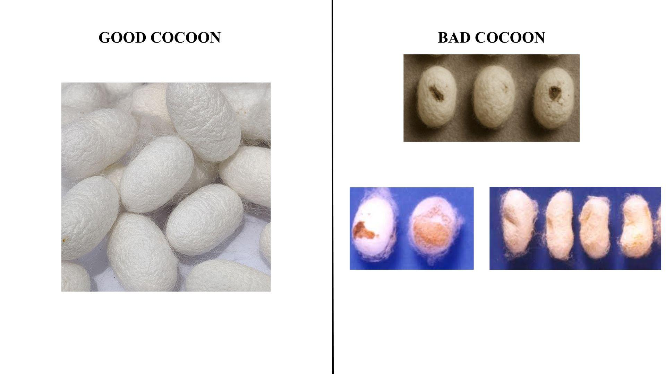
Fig.1.2.1: Visual Comparison Showing Characteristics of Good Cocoons (left) and Common Defects in Bad Cocoons (right)
Fig.1.2.1 shows a visible difference between good and damaged cocoons based on uniformity, shapes, and colors. Good cocoons have smooth and uniformly structured texture, signifying healthy production of silk threads. Damaged cocoons have irregularities like spots, shape, and texture. It shows the importance of automated analysis for reliable quality determination.
1.3 Problem statement
Cocoon sorting in sericulture is still a manual, slow, and inconsistent process. The entry of defective cocoons into the reeling units results in filament breakages and low reeling efficiency. Most small and medium rearing units cannot afford advanced machinery with built-in sorting mechanisms. There is a strong need for low-cost sensor-based and vision-driven automatic cocoon detection, classification, and routing before reeling to reduce labour dependency and improve raw silk quality, thereby modernising the traditional handling of cocoons.
1.4 OBJECTIVES
- Capturing cocoon images in real time with a camera module to assess quality while moving through the tunnel.
- To enhance dataset diversity through advanced augmentation techniques such as CAE-generated synthetic samples, ensuring robust and generalized model performance.
- To classify cocoons as good or defective by using a trained YOLO-based computer vision model.
- In order to reduce manual labor, human error, and sorting time, and improve the efficiency of pre-reeling in small- and medium-scale sericulture units.
- To provide a low-cost automation solution that can be integrated into traditional reeling workflows without requiring expensive machinery.
1.5 Motivation
Sericulture is a major cottage industry activity in the life of farmers and small-scale entrepreneurs in Karnataka, particularly in districts surrounding Mysuru where mulberry cultivation and cocoon production are well established. At the same time, despite technological growth in other agricultural sectors, cocoon sorting and pre-reeling are still labour-intensive, with high manpower involvement. Workers are continuously engaged in the visual judgement-based inspection, identification, and sorting of good cocoons from defective ones. This repetitive process is particularly time-consuming and physically draining under the humid and high-temperature conditions in reeling houses. Inconsistency in manual sorting leads to a number of problems in the reeling industry, resulting in defective or thin-shelled cocoons accidentally entering the reeling basin and leading to frequent thread breakage, lower reelability, reduced raw silk recovery, and fluctuating denier uniformity, which influences the income of reelers. It is not possible for small and medium-scale sericulture units, which form the backbone of the industry, to invest in high-end automatic reeling machines with built-in sorting mechanisms. This results in a serious technological gap where conventional practices continue to rely wholly on human labour. Similarly, skilled manpower in sericulture among the young is rapidly decreasing, causing labour shortages and uncertain delays. Modernization with affordable automation at this stage shall greatly reduce dependence on manpower and, while improving productivity, ensure that the raw silk produced is stable in quality. The prospect of integrating simple electronics and sensors, machine learning, at low cost—instead of expensive industrial equipment—fuels the core inspiration behind this project. The need to support small reeling units, enhance accuracy, reduce human fatigue, and upgrade the technological profile of a traditional industry motivates the development of an automated cocoon detection and sorting system. Combining the strengths of embedded systems with computer vision, the goal is to present a practical and scalable solution that directly benefits sericulture workers by improving the overall efficiency in the production of silk.

CHAPTER 2
LITERATURE SURVEY
- Fine-Grained Detection Model Based on Attention & Multi-Scale Feature Fusion for Cocoon Sorting (2024)
- Method: AMMF-Net (HFE-Net + Transformer, EMFF neck + RetinaNet head).
- Data/Hardware: Cocoon images + VOC07/12; trained on NVIDIA RTX 3090.
- Result: Improved mAP vs. RetinaNet and other baselines.
- Limitation: Single-site bias, bounding-box outputs only, no latency/FLOPs reported.
- Efficient defective cocoon recognition based on vision data for intelligent picking (2024)
- Method: Custom vision + terahertz spectral features + detection network.
- Data/Hardware: 3,762 cocoons, vision sensors, robotic gripper.
- Result: mAP ≈ 99.25% for defect recognition; provides pick coordinates for robotic picking.
- Limitation: Requires full hardware installation; focuses on defects rather than full grading.
- Real-time fine-grained detection of silkworm cocoon defects based on enhanced YOLOX-s (2025)
- Method: Enhanced YOLOX-s deep learning model for real-time detection.
- Data/Hardware: Large real-time cocoon image set (size undisclosed), camera system.
- Result: Real-time defect detection capability.
- Limitation: High GPU requirement; dataset details and generalization not fully reported.
- Automated Prototype for Bombyx mori Cocoon Sorting Using Computer Vision + Light-Transmission Sensing (Sensors, MDPI, 2023)
- Method: HSB thresholding image pipeline combined with photodiode matrix + logistic regression.
- Data/Hardware: GigE cameras (Manta G-504B/C), 7×5 photodiode matrix, Arduino Portenta H7.
- Result: Successful prototype sorting (healthy vs stained/dead) with high accuracy.
- Limitation: Scalability and robustness under variable lighting; logistic regression may miss complex features.
- A Multi-Sensor System for Silkworm Cocoon Gender Classification (2019)
- Method: Image features (area, perimeter, shape) + weight → SVM classifier.
- Data/Hardware: 167 cocoons (CSR2 & Pure Mysore), load sensor, backlit camera, conveyor.
- Result: ≈93.5% accuracy for gender classification.
- Limitation: Small dataset, slower throughput (~10.9 s per cocoon), breed-dependent performance.
- A New Method for Grading of Silk Yarn Using Electronic Vision (2012)
- Method: Image analysis of texture and intensity for yarn grading.
- Scope: Yarn-level (Tasar silk skeins), not cocoon-level.
- Limitation: Relies on consistent imaging conditions; not directly applicable to cocoon grading.
- Smart Automated Sericulture Based on Image Processing & Embedded System (2022)
- Method: Image processing + CNN for healthy/unhealthy silkworm detection; environmental monitoring via sensors.
- Hardware/Software: Arduino Mega, webcam, humidity/temp sensors; MATLAB and Arduino IDE.
- Result: CNN classification ≈82.75%; environmental control automation.
- Limitation: Needs larger labeled datasets; heavy computation for CNNs; may need GPUs for scaling.
- Cocoon Quality Assessment Using Vibration Impact Acoustic Emission (2019)
- Method: Vibration impact + acoustic emission analysis (FFT, PSD, spectral subtraction).
- Hardware: Servo vibration unit, microphones, Arduino, cocoon holder.
- Result: 100% accuracy on 86 lab samples (Good vs Defective).
- Limitation: Very small dataset; lab setting only; method limited to acoustic-detectable defects.
- Advancement in Sericulture Using Image Processing (2024)
- Method: Mobile camera image acquisition, dataset annotation, YOLO training for real-time detection/classification.
- Hardware/Software: Mobile camera, embedded device, Python + PyTorch + OpenCV.
- Result: Real-time classification of cocoons (good vs defective).
- Limitation: Sensitive to environmental factors (lighting, background); limited classification scope.
- Image-based Eri Silkworm Pupa Grading Using Neural Networks (2022)
- Method: Image segmentation + shape/color/size features → neural network grading into 5 size classes.
- Hardware: Fixed camera & standard lighting.
- Result: High accuracy grading for eri pupae.
- Limitation: Region/species dependent and requires standardized imaging.
- Integrated Analysis of ML & DL for Silkworm Pupae Recognition (2023)
- Method: Hybrid: HOG feature extraction + ConvNeXt-S + SVM/MLP/RF classifiers.
- Data/Hardware: 3,600 pupae images; imaging setup with illumination.
- Result: Recognition/classification accuracy ≈99.09% (sex/species).
- Limitation: Focused on pupae recognition (sex/species), not full cocoon quality/grading.
- Deep Learning Enhanced Terahertz Imaging of Silkworm Eggs (2021)
- Method: THz + optical imaging, YOLOv4, SCPDarknet53 for feature extraction.
- Hardware: THz imaging system, high-end GPU (TITAN RTX).
- Result: Up to 99.2% accuracy for developmental stage recognition.
- Limitation: Specialized imaging hardware, single species, limited temporal window.

Research Gap
- Limited real-world robustness: Many vision-based studies achieve high accuracy in laboratory or single-site datasets, but they often rely on controlled lighting, backlit setups, or specialized sensors (THz, photodiode matrices). Such conditions reduce generalizability to field environments (farm/rearing centres).
- Narrow scope of classification: Several works classify only binary labels (good/defective) or narrow tasks (gender, pupae stage). There is a lack of fine-grained, multi-class cocoon grading systems that detect practical factory categories (double cocoon, stained, pierced, immature, flimsy).
- Hardware–software integration gap: Few papers present end-to-end systems that integrate low-cost sensors (IR, LDR), embedded controllers (Arduino/ESP32), actuators (servo/gates), and computer vision for real-time sorting at conveyor speeds. Prototype works exist but often lack scalability or real-time latency analysis.
- Small datasets & reporting: Some high-accuracy claims are based on small datasets (e.g., 86 samples or under 200 cocoons) or undisclosed datasets, limiting reproducibility. Larger, diverse, annotated datasets and metrics like latency/FLOPs are often missing.
- Cost and accessibility: Methods using THz or high-end imaging are not cost-effective for small farmers/cluster reelers. There’s a need for low-cost, robust approaches deployable in field conditions.
The project targets these gaps through the implementation of a low-cost, embedded, real-time cocoon grading and sorting system. It integrates vision with IR/LDR sensing and servo actuation to achieve multi-class grading practical for field conditions.
Based on the literature review, it was realized that accuracy can be achieved using AI-based cocoon detection techniques, but they are applicable under controlled illumination conditions and thus with expensive sensors or high-end GPUs. It was realized that most research works concentrate on binary classification and are limited by datasets, throughput rates, or an un-integrated hardware and software platform. Nonetheless, these research works underscore a gap that needs to be satisfied with an appropriate sorting system. The project will fill these gaps with cheaper sensors, CAE-enhanced datasets, and an end-to-end software and hardware platform.

CHAPTER 3
METHODOLOGY
3.1 Dataset Acquisition
It started with the image acquisition of cocoons under controlled conditions. The camera was placed above the tunnel section and captured the high-resolution images of both normal and defective cocoons-stained, pierced, double, and flimsy. Each cocoon was manually labeled according to its category. About 305 were gathered that included variations in lighting and different orientations of the cocoons.
Components used:
- Camera: Intel REALSENSE Depth Camera (D345i)
- Lighting: LED panels
- Frosted Glass: White matte background for contrast
- Computer: Local system for image storage and labeling
3.2 Data Augmentation
Data augmentation was used to increase dataset diversity and avoid overfitting. Rotation, flipping, scaling, brightness adjustment, and translation were used in the generation of the dataset. Further, the Conditional AutoEncoder was applied to generate synthetic images that captured minor changes in the appearance of cocoons without changing class labels. This enhanced model generalization during training.
3.3 Model Training
The augmented dataset was further split into 70% for training, 20% for validation, and 10% for testing. YOLOv8 has been preferred owing to efficiency in real-time object detection.

Workflow:
- Loading images and annotations.
- Setting up the YOLOv8 model: backbone, neck, head.
- Training with hyperparameters: learning rate, batch size, and epochs.
- Validation to monitor loss, precision, recall, and mAP.
- Testing on unseen images for the evaluation of generalization.
Software/Hardware: PyTorch, Ultralytics YOLOv8 framework Python 3.11, OpenCV
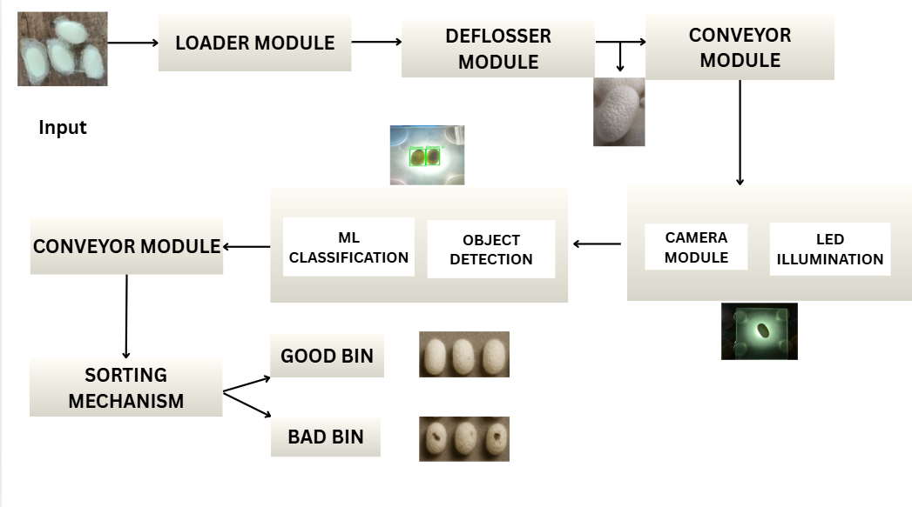
Fig.4.1. Block diagram of proposed system

CHAPTER 4

SYSTEM REQUIREMENTS
This chapter outlines the complete hardware and software requirements essential for developing and operating the Cocoon Automation System. The system is composed of six major modules:
- Loader
- Tunnel
- Deflosser
- Imaging Setup
- YOLOv8 Machine Learning Model
- Automated Sorting Mechanism
Each module contributes to the smooth detection, cleaning, classification, and sorting of cocoons in an automated workflow.

4.1 Functional Requirements

4.1.1. Loader Module
- IR sensor detects the presence of a cocoon.
- The gate opens for 3 seconds and closes for 5 seconds.
- Ensures the cocoon enters the tunnel smoothly.

4.1.2. Tunnel Module

Provides aligned, stable movement of the cocoon.
- Minimizes vibrations for accurate imaging and efficient deflossing.

4.1.3. Deflosser Module
- Removes loose floss from the cocoon surface.
- Adjusts or rotates the cocoon to achieve proper orientation for imaging.

4.1.4. Imaging Setup
- Captures high-resolution images of each cocoon.
- Provides uniform background and consistent lighting.
- Sends image/video frames for YOLOv8 inference.

4.1.5. YOLOv8 Model (Detection + Classification)
- Performs real-time cocoon detection.
- Draws bounding boxes around detected cocoons.
- Classifies cocoon as Good or Bad.
- Sends classification results to the local server for sorting.
4.1.6. Communication Layer (Local Server + Colab)
- Local Flask server handles communication between the YOLOv8 model and microcontroller.
- Colab runs the YOLO model and sends classification via API calls.
- Ensures low-latency and reliable data exchange.

4.1.7. Sorting Mechanism (Servo Motor)
- Receives classification output from the local server.
- Good cocoon → Servo rotates to 45°
- Bad cocoon → Servo rotates to 135°
- Physically directs cocoons into appropriate collection bins.

4.2. Non-Functional Requirements

4.2.1. Performance
- Real-time inference: <100 ms per frame.
- Servo movement response: <1 second.
- Zero missed detections during continuous operation.

4.2.2. Reliability
- Stable communication between Colab → Local Server → Microcontroller.
- Supports 4–6 hours of continuous operation.

4.2.3. Accuracy
- YOLOv8 should maintain high accuracy under variable lighting.
- Correct classification directly impacts correct sorting.

4.2.4. Scalability

The system supports upgrading to YOLOv9 or larger datasets.
- Additional sensors or modules can be integrated easily.

4.2.5. Usability
- Mechanical modules are simple to assemble and maintain.
- Easy image upload and YOLO execution workflow.

4.2.6. Maintainability
- Replaceable components: IR sensor, camera, servo, power supply, tunnel parts.
- Modular code architecture supports quick debugging.

4.3. Hardware Requirements
Component | Purpose / Specification
Arduino UNO / ESP32 | Controls loader gate and sorting servo
IR Beam Sensor | Detects presence of cocoon in loader
Servo Motor (SG90 / MG995 – 180°) | Used for sorting: 45° = Good, 135° = Bad
Servo / DC Motor (180°) | Operates loader gate mechanism
Intel RealSense Depth Camera / High-res Camera | Imaging for YOLO model
LED Lighting (15W panel) | Provides uniform illumination for consistent detection
360° Servo Motors | Rotate deflosser brushes
Deflosser Mechanism | Removes loose floss from cocoon
Tunnel Assembly | Ensures smooth and aligned cocoon movement
5V Power Supply | Powers motors, sensors, and microcontroller
Mechanical Frame | Supports loader, tunnel, deflosser, and camera modules

4.4 Software Requirements

4.4.1. Microcontrollers
- Arduino IDE
- Servo Motor Library
- Digital I/O Control Modules

4.4.2. Model & Server
- Python (Google Colab)
- YOLOv8 (Ultralytics)
- Flask (Local Server)
- Requests Library (for API communication)

4.4.3.System Software
- Windows / Linux PC
- USB Serial Drivers.
- Web Browser (for accessing Colab and local server)

CHAPTER 5
IMPLEMENTATION
The implementation pipeline of AutoCocoon combines mechanical handling, imaging, dataset enhancement, AI-based classification, and automated sorting. Each stage is optimized to maintain consistency and accuracy.

5.1 Loading and Feeding mechanism
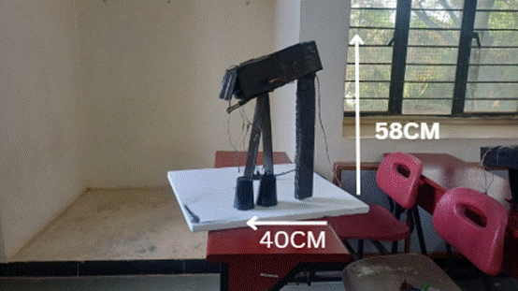
Fig.5.1.1. Loader module
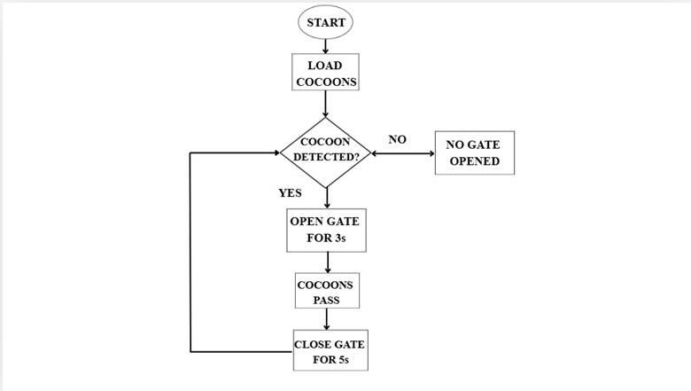
Fig.5.1.2. Flowchart for loader
Fig.5.1.1 shows the automated loader unit where cocoons are fed into the system.This IR sensor will detect each cocoon and allow gate movement.The design is such that it ensures one cocoon enters at a time without overlap.It lays the foundation for the starting control point for the whole automation workflow.
Fig.5.1.2. depicts the decision-making steps for the loader module.It shows cocoon detection, gate opening, timed delay, and gate closing.It ensures that there is synchronized feeding prior to imaging and sorting.This sequence avoids clogging or the entry of double cocoons.

5.2 Deflossing
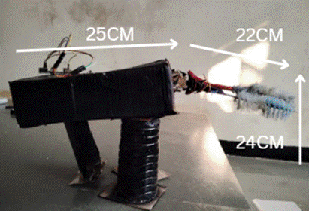
Fig.5.2. Deflosser module

Fig.5.2. shows the rotating-brush deflossing mechanism.Brushes driven with continuous rotation motors remove surface floss.The cocoon is not broken during this time; only the loose fibres are cleaned.This step allows for better clarity of the image for defect detection.

5.3 Imaging and Illumination
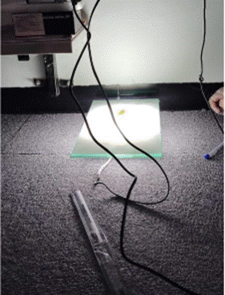
Fig.5.3. Imaging setup
Fig.5.3. Overview of the camera and LED illumination system setup.This provides uniform lighting that eliminates shadows and thus helps in clear visibility of the cocoons.This is meant to provide exactly the same image capture for all samples with a fixed camera angle.Improves YOLO detection accuracy and makes models consistent.

5.4 Dataset Preparation
To address the limited number of real cocoon samples, a Convolutional Autoencoder (CAE) was used to generate augmented images.
This process helped artificially expand the dataset while preserving realistic cocoon features such as texture, color gradients, and shape.

Key steps:
- Original Image Collection:
Initially, 305 clean cocoon images were collected under controlled lighting conditions.
- CAE Training:
A convolutional autoencoder was trained on these images to learn the latent feature representation of cocoon characteristics.
- Generating Augmented Samples:
The trained CAE produced reconstructed and slightly varied images that remained visually close to the originals while introducing minor, natural variations.
- Quality Validation:
Structural Similarity Index Measure (SSIM) was used to validate the augmented images.The average SSIM score of 0.9909 indicated that the augmented images closely resembled real cocoons while avoiding redundancy.
- Dataset Expansion:
Using CAE outputs along with basic rotation and flipping augmentations, the dataset was expanded from 305 images to approximately 689 images.
This larger and more diverse dataset provided the YOLOv8 model with a stronger foundation for learning, improving both robustness and real-world accuracy.

5.5 Training the model

The augmented dataset was used to train a YOLOv8 binary classification model. Cocoons were labeled as Good (Conforming) or Defective (Non-Conforming).
Training details:
- Epochs: 300
- Optimizer: AdamW
- Learning Rate: 0.0001 → decayed gradually
- Augmentations disabled: mosaic=0, mixup=0, translate=0
This preserves natural cocoon appearance.
- Backbone + Neck: FPN and PAN for multi-scale feature fusion
The large augmented dataset improved the model’s ability to recognize variations in cocoon shape, density, and defects, resulting in enhanced precision and recall during testing.

5.6 Deep Learning–Based Cocoon Quality Classification
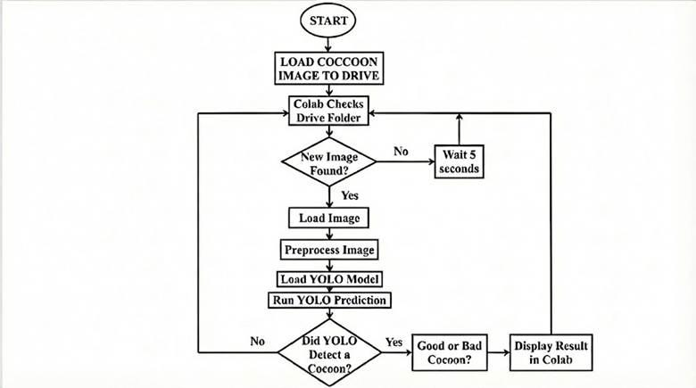
Fig.5.6. Yolo model flowchart
Fig.5.6. highlights the flowchart representing the YOLOv8 detection and classification process.It illustrates image acquisition and preprocessing, cocoon detection, as well as classification.It generates labels as well as confidence values (Good/Bad).It directs the subsequent sorting process.

During real-time operation, each cocoon image is passed through the YOLOv8 model running on the colab. The model performs:
- Object detection
- Cocoon localization
- Binary classification (Good / Defective)
This entire process occurs in milliseconds, enabling high-throughput sorting.

5.7 Automated Sorting
Once classified, the system immediately activates the corresponding actuator:
- Good cocoons → directed to the accepted bin
- Defective cocoons → directed to the rejected bin
Servo gates or solenoid flaps move in real time, ensuring accurate sorting without human intervention.

CHAPTER 6
RESULTS

6.1 Loader Module Implementation
The loader uses an IR sensor to detect the presence of a cocoon. Once detected:
- The loader gate opens for 3 seconds
- Then it closes for 5 seconds
- Only one cocoon is allowed at a time, preventing overlaps or double feeding
A microcontroller (Arduino/ESP32) controls the servo motor for the gate. This ensures that cocoons enter the tunnel uniformly and at controlled intervals, improving imaging accuracy.
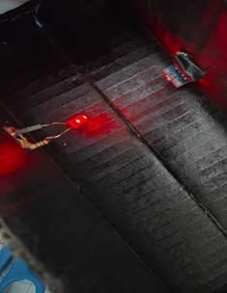
Fig.6.1. Loading with IR sensor
Fig.6.1. illustrates the applied IR-based loader during an actual operation.The IR beam detects every cocoon that is coming inside the gate area.This triggers timed gate opening/closing controlled by a servo.It ensures the continuous and precise feeding.

Tunnel and Alignment System
A smooth PVC/metallic tunnel was installed to guide the cocoon.
The tunnel:
- Maintains proper orientation
- Reduces vibration
- Ensures stable motion before entering the deflosser
The aligned tunnel helps maintain consistent imaging positions and prevents random rotations.

6.2 Deflosser Module Implementation
The deflosser uses:
- 360° continuous servo motors
- Rotating brushes
The mechanism gently removes loose floss before imaging.
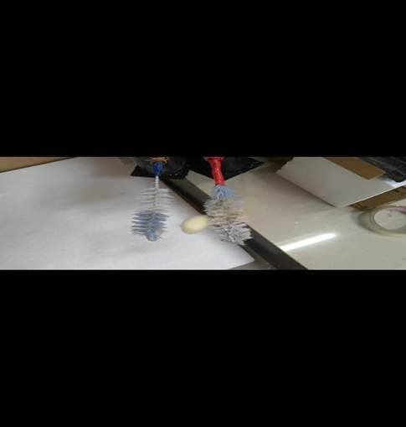

Fig.6.2 : Deflossing of cocoon
Fig.6.2. shows the deflossing mechanism in action. The rotating brush attachments gently remove the loose silk floss from the surface of the cocoon as it passes along the guided track. The cocoon is positioned under the brushes, and as the motor rotates, the bristles sweep away the outer floss layer without damaging the cocoon structure. This stage ensures that only clean and uniform cocoons proceed to the next step in the automation process, thereby improving both accuracy and efficiency in the overall workflow.During testing, complete deflossing of a batch took approximately 9 minutes, depending on floss density.The rotation speed was optimized so the cocoon is cleaned without damage.

6.3 Imaging Setup Implementation
A high-resolution Intel RealSense d435i or USB camera was mounted above the tunnel.
Key features implemented:
- Fixed-angle mounting for consistency
- 15W LED panel for uniform and shadow-free lighting
- Background isolation to avoid false detections
The camera streams frames to a Python script running YOLOv8.

6.4 YOLOv8 Model Implementation
The system uses YOLOv8 for:
- Cocoon detection
- Classification into Good or Bad
Training Pipeline:
- Data augmentation using CAE
- Flipping, brightness correction, rotation, and noise reduction
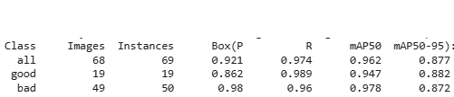Fig.6.4.1. Yolov8 Performance metrics
Fig6.4.1 display accuracy curves including precision, recall, and loss.It highlights progress made on the model with regards to the number of epochs.It can be seen that there are high precision and recall values, which depict good defect detectionIt shows that the training process and data set are valid.

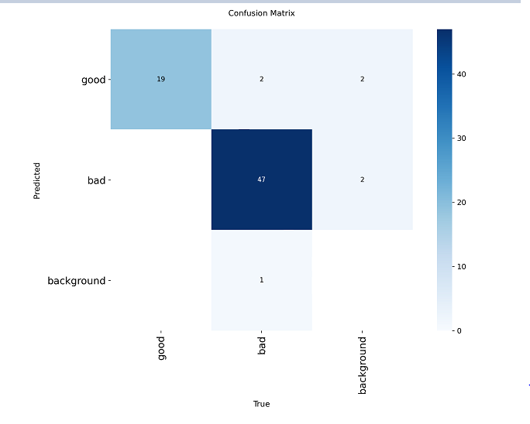
Fig.6.4.2. Confusion matrix for training set
Fig.6.4.2 shows how well the model differentiates Good vs Bad cocoons.High diagonal values indicate correct classifications.Low off-diagonal values mean few misclassifications.It reflects the robustness of the trained YOLOv8 model.

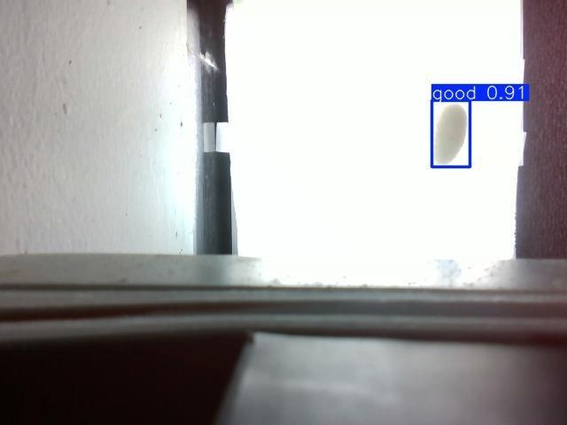
Fig.6.4.3. Good cocoon detected
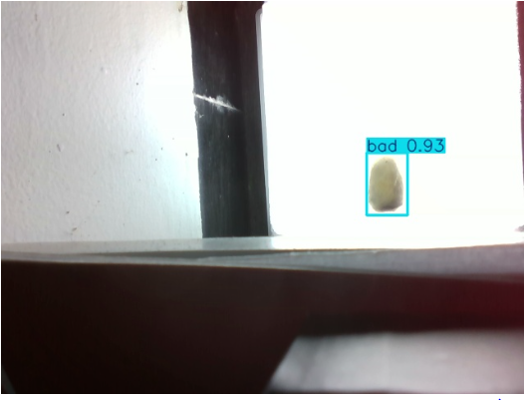
Fig.6.4.4.Bad cocoon detected
Fig.6.4.3 and Fig.6.4.4 displays the real-time cocoon detection results obtained using the YOLOv8 model. The model successfully identifies the cocoon placed on the surface and highlights it with a bounding box. The detected class label “ bad cocoon” and “good cocoon” along with the confidence score is shown above the bounding box, indicating the accuracy of the model's prediction.This output verifies that the trained YOLOv8 model is capable of accurately detecting cocoons in varying lighting conditions and backgrounds, enabling reliable automation for subsequent processes such as deflossing, sorting, and loading. The result also demonstrates that the computer vision pipeline is functioning correctly during inference, with smooth integration between data acquisition and model execution.

6.5 Sorting Mechanism Implementation
A servo motor was programmed as follows:
- Good cocoon → 45°
- Bad cocoon → 135°
The chute physically directs cocoons to their respective bins. Response time was less than 1 second, enabling continuous sorting.
CHAPTER 7
CONCLUSION AND FUTURE WORK
Based on the findings from this work, the developed automated system successfully integrates cocoon handling, deflossing, and imaging with deep-learning-based quality classification into a streamlined workflow. This system, by fusing sensors, embedded control, and vision processing with YOLOv8, minimizes human intervention while greatly improving accuracy, speed, and consistency in the operations. The expansion of the dataset using a Convolutional Autoencoder greatly enhanced the model robustness and enabled the reliable real-time grading of cocoons under variable lighting and other environmental conditions.
The future works will focus on enhancing multi-class classification to identify more cocoon categories, such as double, pierced, immature, or flimsy cocoons. Thousands of samples in various backgrounds will make the scalability of the dataset perfect. Hardware improvement includes faster actuators, synchronized conveyor systems, and edge-device deployment, which will make the system industrially viable. Integration with a wireless monitoring dashboard and predictive maintenance analytics will further enhance the applicability at sericulture units.

BIBLIOGRAPHY
[1] H. Zheng, X. Guo, Y. Ma, X. Zeng, J. Chen, and T. Zhang, “Fine-grained detection model based on attention mechanism and multi-scale feature fusion for cocoon sorting,” Agriculture, vol. 14, no. 5, p. 700, 2024, doi: 10.3390/agriculture14050700.
[2] Jun Chen, Xueqiang Guo, Taohong Zhang, Han Zheng. Efficient defective cocoon recognition based on vision data for intelligent picking[J]. Electronic Research Archive, 2024, 32(5): 3299-3312. doi: 10.3934/era.2024151.
[3] Vasta, Simone, Simone Figorilli, Luciano Ortenzi, Simona Violino, Corrado Costa, Lavinia Moscovini, Francesco Tocci, Federico Pallottino, Alberto Assirelli, Alessio Saviane, and et al. 2023. "Automated Prototype for Bombyx mori Cocoon Sorting Attempts to Improve Silk Quality and Production Efficiency through Multi-Step Approach and Machine Learning Algorithms" Sensors 23, no. 2: 868. https://doi.org/10.3390/s23020868.
[4] A. Pal, T. Dey, P. Chopra, A. Akuli, M. Ray and N. Bhattacharva, "A new method for grading of silk yarn using electronic vision," 2012 Sixth International Conference on Sensing Technology (ICST), Kolkata, India, 2012, pp. 387-392, doi: 10.1109/ICSensT.2012.6461706.
[5] Joseph Raj, Alex Noel, Rahul Sundaram, Vijayalakshmi G.V. Mahesh, Zhemin Zhuang, and Alessandro Simeone. 2019. "A Multi-Sensor System for Silkworm Cocoon Gender Classification via Image Processing and Support Vector Machine" Sensors 19, no. 12: 2656. https://doi.org/10.3390/s19122656.
[6] P.P. Prasobhkumar, C.R. Francis, Sai Siva Gorth, Cocoon quality assessment system using vibration impact acoustic emission processing, Engineering in Agriculture, Environment and Food, 2019, Volume 12, Issue 4, Pages 556-563, Released on J-STAGE September 27, 2023. Online ISSN 1881-8366, https://doi.org/10.1016/j.eaef.2019.11.008, https://www.jstage.jst.go.jp/article/eaef/12/4/12_556/_article/-char/en
[7] Yogeshraj, N. S. "Smart automated sericulture based on image processing technique and embedded system." Journal of University of Shanghai for Science and Technology 24, no. 1 (2022): 327-331.
[8] Kumar, K., Pavan, N., Yashas, R., Rajesh, R., Rakshith, B.G. (2024). Advancement in Sericulture Using Image Processing. In: Gunjan, V.K., Kumar, A., Zurada, J.M., Singh, S.N. (eds) Computational Intelligence in Machine Learning. ICCIML 2022. Lecture Notes in Electrical Engineering, vol 1106. Springer, Singapore. https://doi.org/10.1007/978-981-99-7954 7_61
[9] R. N. Sharifbayev, Sh. S. Djurayev, A. A. Khoshimov, S. S. Sharipbayev, Sherzod Kurambayev; AI-driven cocoon classification for silk production. AIP Conf. Proc. 21 July 2025; 3304 (1): 030033. https://doi.org/10.1063/5.0269511
[10] Liu, Jiajia, Jiapeng Zhang, Zhongli Ma, Enhao Li, and Jianying Yuan. "An online quality detection algorithm for cocoon clusters based on CD YOLO." IEEE Access (2024).
[11] Cohesion Test Method for Identifying Dried Cocoon Raw Silk.China Patent CN109490123A. Filed November 2, 2018, and issued March 19, 2019. Accessed September https://patents.google.com/patent/CN109490123A/en. 19, 2025.
[12] Li Guanghui, Zhang Zhen, Huang Licai, Lü Guang, Li Dongyang, and Wu Rentian. "Cocoon Blowing Type Intelligent Silkworm Cocoon Sorting Machine." CN216064327U, filed May 17, 2021, and published March 18, 2022. Liuzhou Chengming Technology Co Ltd.
[13] Zheng Zuofu, Lin Haitao, Zhao Xinyu, Li Linbei, Yin Bo, Mao Xiuyong, and Xu Jialiang. "Pneumatic High-Speed Cocoon Selecting Device." CN112547566B, filed December 23, 2020, and published January 17, 2025. Guangxi University of Science and Technology.
[14] Lin, Jiewen, Gui Hu, and Jian Chen. "A data augmentation method for computer vision task with feature conversion between class." Computers and Electronics in Agriculture 231 (2025): 109909. [15] Chadebec, Clément, Elina Thibeau-Sutre, Ninon Burgos, and Stéphanie Allassonnière. "Data augmentation in high dimensional low sample size setting using a geometry-based variational autoencoder." IEEE Transactions on Pattern Analysis and Machine Intelligence 45, no. 3 (2022): 2879-2896.
[16] Li, Huipeng, Congqing Wang, and Yang Liu. "Aircraft Skin Defect Detection Based on Fourier GAN for Data Augmentation." In 2024 international conference on advanced robotics and mechatronics (ICARM), pp. 449-454. IEEE, 2024.
[17] Shen, Jianghao, and Tianfu Wu. "Learning spatially-adaptive squeeze excitation networks for few shot image synthesis." In 2023 IEEE Interna

BMS INSTITUTE OF TECHNOLOGY AND MANAGEMENT
AVALAHALLI, DODDABALLAPUR MAIN ROAD, BANGALORE-64
DEPARTMENT OF ELECTRONICS AND COMMUNICATION ENGINEERING

STUDENTS PROFILE

Sl No | Name | USN | Photograph | Mail id | Phone Number
1 | Akshaya Ramesh | 1BY23EC009 |  | akshayaramesh249@gmail.com | 8217477535
2 | Ashitha M | 1BY23EC024 |  | ashitha0207@gmail.com | 8431750512
3 | Raman R | 1BY23EC085 |  | ramanrajesh1111111@gmail.com | 8123361923
4 | Vibha I S | 1BY23EC122 |  | Vibha92005@gmail.com | 9483018150

